LAB Logbook

Lab 1

Lab 2

Lab 3

Lab 4

Lab 5

**Model: "sequential"**

┏━━━━━━━━━━━━━━━━━━━━━━━━━━━━━━━━━┳━━━━━━━━━━━━━━━━━━━━━━━━┳━━━━━━━━━━━━━━━┓

┃ **Layer (type)** ┃ **Output Shape** ┃ **Param #** ┃

┡━━━━━━━━━━━━━━━━━━━━━━━━━━━━━━━━━╇━━━━━━━━━━━━━━━━━━━━━━━━╇━━━━━━━━━━━━━━━┩

│ conv2d (Conv2D) │ (None, 29, 29, 32) │ 1,568 │

├─────────────────────────────────┼────────────────────────┼───────────────┤

│ max_pooling2d (MaxPooling2D) │ (None, 14, 14, 32) │ 0 │

├─────────────────────────────────┼────────────────────────┼───────────────┤

│ conv2d_1 (Conv2D) │ (None, 12, 12, 64) │ 18,496 │

├─────────────────────────────────┼────────────────────────┼───────────────┤

│ max_pooling2d_1 (MaxPooling2D) │ (None, 6, 6, 64) │ 0 │

├─────────────────────────────────┼────────────────────────┼───────────────┤

│ conv2d_2 (Conv2D) │ (None, 4, 4, 128) │ 73,856 │

├─────────────────────────────────┼────────────────────────┼───────────────┤

│ max_pooling2d_2 (MaxPooling2D) │ (None, 2, 2, 128) │ 0 │

├─────────────────────────────────┼────────────────────────┼───────────────┤

│ flatten (Flatten) │ (None, 512) │ 0 │

├─────────────────────────────────┼────────────────────────┼───────────────┤

│ dense (Dense) │ (None, 10) │ 5,130 │

└─────────────────────────────────┴────────────────────────┴───────────────┘

**Total params:** 99,050 (386.91 KB)

**Trainable params:** 99,050 (386.91 KB)

**Non-trainable params:** 0 (0.00 B)

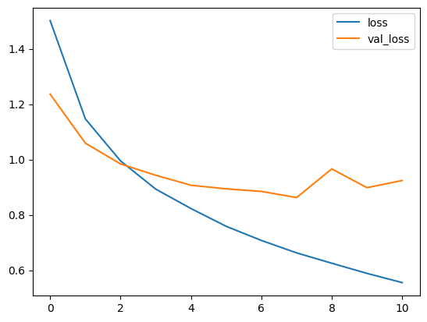

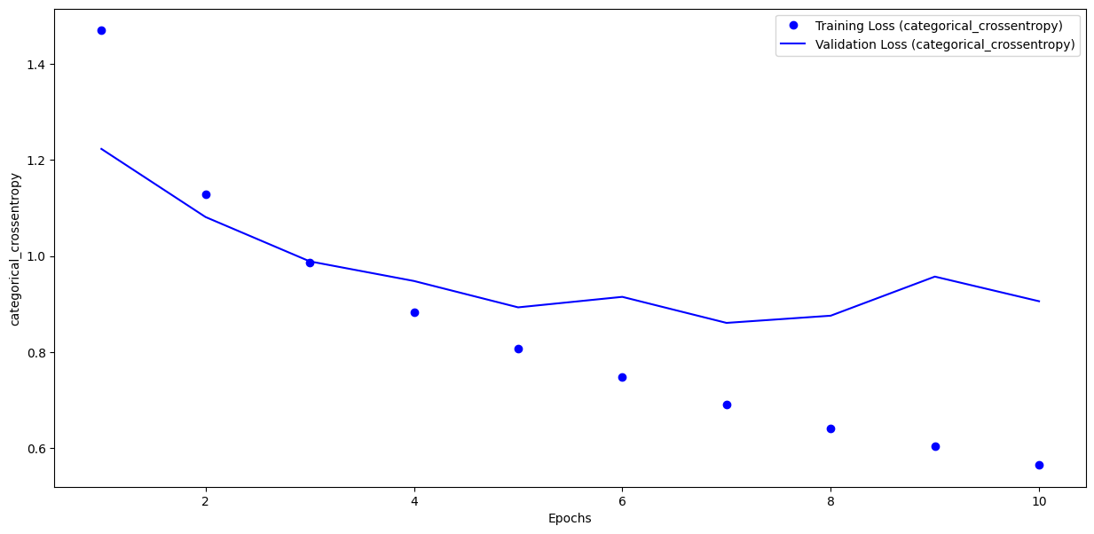

**The optical number of epochs for training my model would be 4-6,** as after 5 epochs the validation loss starts to either increase or not improve.

Lab 6

Lab 7

Lab 8

Lab 9

Lab 10

Lab 11

Lab 12